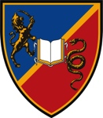

PRACTICAL INFORMATION FOR THE EBM 2016 CONFERENCE PARTICIPANTS

The following document will give you a set of brief and useful information on travel, accommodation and other conference related matters. We would like you to have a wonderful experience at the EBM 2016 Conference and should you need any additional information please do not hesitate to contact us by sending an e-mail to: ebm2016@kg.ac.rs

1. Arriving to Serbia/Kragujevac

By plane: Most of the major European airline carriers and low cost companies fly to Belgrade on a daily basis, including WizzAir, AirFrance, Alitalia, Austrian, British Airways, Lufthansa and Swiss. For more information you can visit Belgrade Airport web site or contact Belgrade Airport flight information desk by calling: + 381 11 209 4444.

Airport is located approximately 20km from downtown Belgrade and about 165 km from Kragujevac. You can get to downtown Belgrade by bus shuttle operated by Belgrade’s Public Transportation Company or by using a taxi service to take you directly to the Belgrade’s bus station. Approximate price of certified taxi service is 20EUR.

Once you get to the Belgrade’s Bus Station you can take a bus directly to Kragujevac. Approximate two-way ticket price is 20EUR. Upon arriving to Kragujevac Bus Station you can take a taxi to a hotel or to the Faculty of Economics. The price of taxi services is approximately 1 euro/km.

By rent-a-car: You can rent-a-car at the Belgrade Airport. Leave the airport and take the road direction to Belgrade/Niš on E70 highway. Once you pass Belgrade, stay on the course to Niš for about 115km and once you get to Batočina exit the highway heading to Kragujevac (see Map 1 on the next page). It will take you another 25km to arrive to Kragujevac.

2. Conference Venue and Hotels

The Conference will take place at the Faculty of Economics – University of Kragujevac.

There are several different accommodation options available in Kragujevac. Available accommodation options are shown on the last page of this document.

3. Registration and Reception

The registration desk will be open on Thursday, November 09, from 8:00 to 10:00 at the Conference venue.

The Plenary sessions will take place at the Faculty of Economics and the Conference sections will take place in different rooms of the Faculty. An updated timetable with details of each event will be included in the Registration Pack.

4. Good things to know

The currency used in Serbia is Dinar (RSD). Hotels should be able to change your money at the Reception desk. If your hotel does not have this service, you will find banks nearby by where you will be able to do so. Employees at the Reception desk usually do speak English, so feel free to ask them for additional information.

It is not mandatory to leave tips in restaurants and bars. If you think you have had a very good service, then you may leave a tip, which is 5-10% of the bill.

Map 1: Getting from Belgrade Airport to Kragujevac

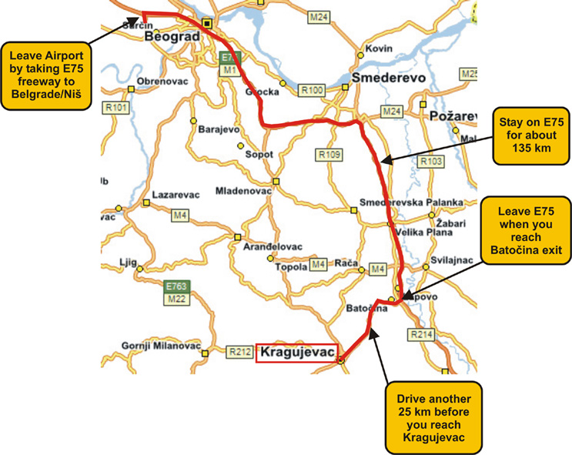

Map 2: Available accommodation in Kragujevac

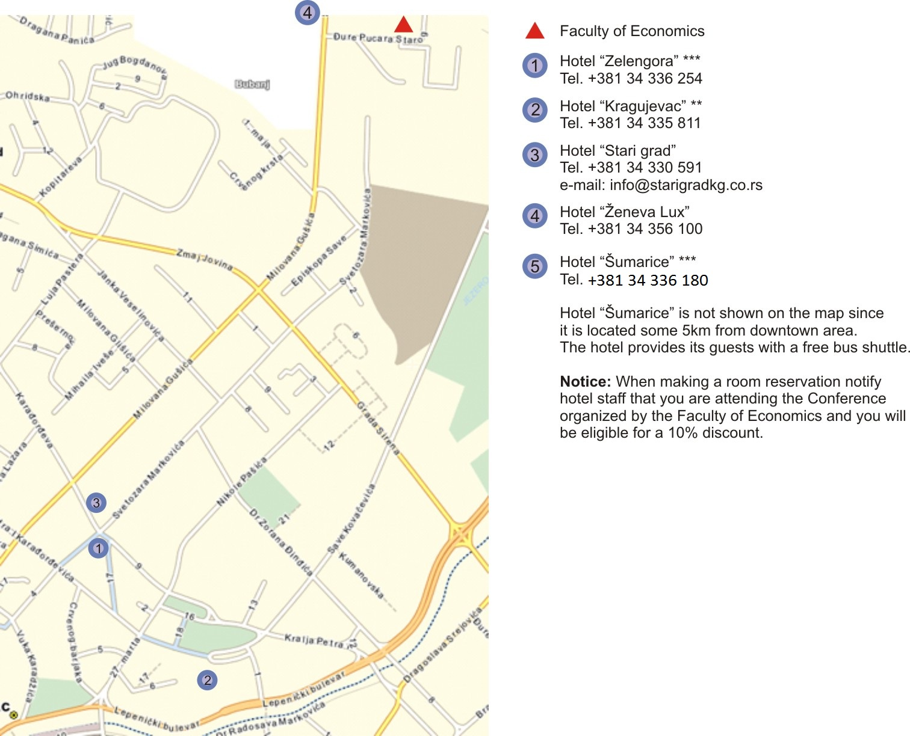

All hotels numbered 1 through 3 are on walking distance, 1-2km from the Faculty.

5. About the Faculty of Economics

The Faculty of Economics – University of Kragujevac is a nationally accredited higher education institution that is marking the 56th year of its existence in 2016. Throughout its history the Faculty of Economics strived to establish a respectable position in the region of the Balkans in terms of scientific contribution, as well as, in terms of providing high-class education in the fields of economy and management. In that respect, the Faculty of Economics has continuously worked on improving its curriculums, aligning them with the latest trends.

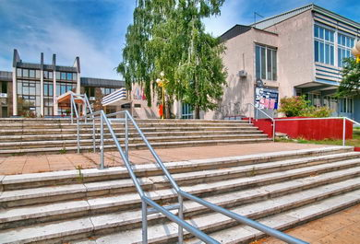

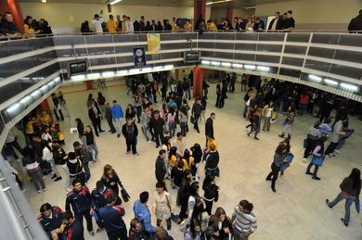

6. About the city of Kragujevac

Kragujevac is the largest city of the District of Šumadija and the fourth largest city in the Republic of Serbia. The total population is estimated at 180.250. With an absolute right, Kragujevac holds the title of the cradle of modern Serbia. Kragujevac was nation’s first capital after liberation from the Ottomans in the period between 1818 and 1841. During this period numerous state institutions were established for the first time in Serbia (Court, National Office, Grammar and High School Lycee, Serbian Majestic Orchestra, Court Theatre, Cannon Foundry, Electrical Power Plant, Pharmacy). Nowadays, Kragujevac is best known for its automobile industry (Fiat Automotive Serbia), hospitality of its inhabitants and the fastest emerging economics spots in the Balkans.

